Test Corrections Rubric Name:
Quiz 17-24
Original Score Received ___________

- When an astronomer discovers a sunspot on the surface of the sun, he/she knows that:

- Earth needs to prepare for possible telecommunication problems from damaged satellites
In answer choice C, what property of the sun is the “arc of fire” referring to?
- Earth will receive more radiation during the sunspot
- It is an arc of fiery gas radiating from the sun, hotter than normal
- The dark spot is caused by material in that area that is cooler than the material around it.

- Which of these scenarios best represents how mountains are formed by tectonic plate movement?
Describe (in your own words) the differences between convergent, divergent and transform boundaries.
- Tree roots pushing up a sidewalk as they grow
- When a glass with ice is filled with water and the ice rises
- A toddler pushes two pieces of paper together and they rise in the middle
- At a carnival, the dunk tank trap door opens, allowing the person to get dunked.

- Hard-boiled eggs have often been used to model the layers of Earth’s interior. Which choice describes how heat would move through Earth’s layers?
- within the yolk only
- from the shell to the yolk
Min 2 sentences describing how heat is transferred from the core to the crust (hint: use the term convection current)
- from the yolk to the white
- around the yolk in the white

- Cellular respiration takes place in the mitochondria of our cells. These are often referred to as the “powerhouse” of the cell. In what part of the body would you find the kinds of cells with a large number of mitochondria?
Name 3 other organelles and their function in a cell.
- Hair Follicle
- Muscle tissue
- Sweat gland
- Cheek cell

- 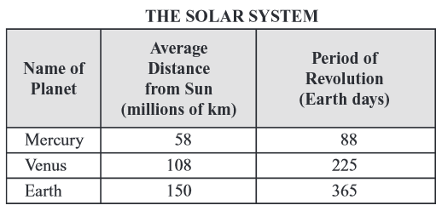The table below shows the distance from the Sun and the period of revolution of the first three planets in the Solar System.

Based on the data in the table, approximately how many planetary years does Mercury complete during the length of time that Earth has one planetary year?
F. Half of a year
G. 4 years
H. 6 years
I. 24 years

Do the math! Show how this problem is worked out.

- Ethan is observing chemical and physical properties of a substance. He heats a substance and observes that the substance turns from a brown solid to a black powder. He refers to several chemistry journals that claim this represents a chemical reaction. From his observation and research, he concludes that the substance goes through a chemical change when heated. How can Ethan best defend his conclusion?
Fill in at least 2 facts for both parts of the Venn diagram. You do not need to fill in the middle part.

- by demonstrating that the substance will eventually melt if the temperature continues to increase
- by verifying that the substance is now made up of different molecules than before it was heated
- by verifying that the substance is made up of only one type of element
- by demonstrating that the substance is less dense after it is heated

- Global climate change has resulted in warming the atmosphere. This has also caused a warming of the world’s water, like oceans and lakes. Warmer water means more evaporation, speeding up the water cycle. What is one effect this could have on climate?

- Sea levels would fall because more water would be stored as clouds
Describe 3 implications of a region experiencing an ongoing drought or flood.
- Areas with more evaporation would have droughts while others would have floods
- There would be more clouds, which will help block sunlight, cooling the Earth
- More evaporation would mean that water in the clouds would burn off faster, making it sunny more often

- Until the 1500’s, most people believed in the geocentric model of the universe. After that, our technology led us to our current heliocentric theory. What does the geocentric model describe?

  - The Earth and all the planets rotate around the Sun
Describe the heliocentric model (2 sentences minimum).
  - The Sun rotates around the Earth and the other planets
  - The moon was actually another planet
  - The Sun and other planets revolve around Earth

Email me this digital copy of the quiz corrections, or print it out and turn into the tray at school. If using email, write “Quiz Corrections 17-24” in the subject line.

Natalie_keene-krops@scps.k12.fl.us

