Matter Study Guide
1. List two examples of a homogeneous solution mixture. Lemonade, salt water, tea
2. List two examples of a heterogeneous colloid mixture. Colloids frequently appear "murky" or "opaque" and seem to be homogenous. The particles are large enough to scatter light. Colloids generally do not separate on standing. They are not separated by filtration. (800mainstreet.com) Ex. Milk, mayonnaise, fog
3. List one example of a heterogeneous suspension mixture. Suspensions are mixtures containing particles that settle out when left undisturbed. They can be separated by filtration. (eduction-portal.com). Ex. Sand in water, Italian salad dressing
4. List two examples of elements. Hydrogen, Oxygen, Iron, Aluminum
5. List two examples of a chemical formula. H2O, CO2, NH3
6. Category of mixture where substances are mixed evenly. Homogeneous
7. Category of mixture where particles are not mixed evenly. Heterogeneous
8. The cloudy type of mixture that can scatter light where particles are too small to settle out. Colloid
9. Type of mixture where particles are large enough to settle out or form layers. Suspension
10. Compare and contrast luminosity, apparent magnitude and absolute brightness. Luminosity is an exact measure, and is does not depend of the distance of an observer. Apparent magnitude is the apparent brightness of a star from Earth. Absolute brightness is a measurable amount of brightness from a set point away from any star.
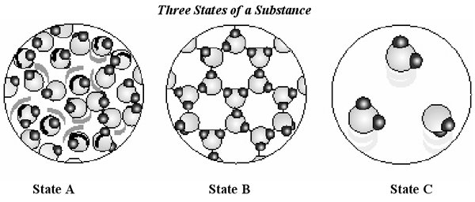
11. In which state are the particles least able to move? B, this is a crystalline solid
12. Which of the three states represents a liquid? A
13. If State A is heated, which of the other two states would it more closely resemble? Explain. C. As heat is added to a liquid, its particles are excited and move further away from each other.
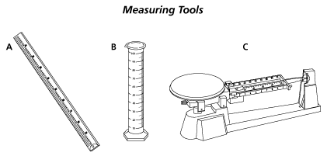

14. What does tool C measure? Mass
15. What does tool B measure? Volume

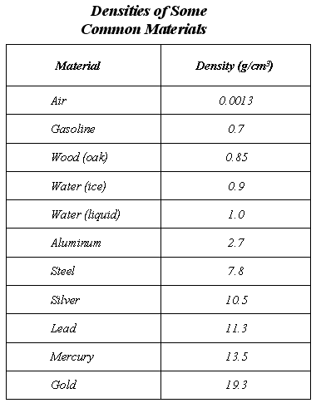
16. Which substance has the lowest density? Air
17. What is one substance that will float in water? Air, gasoline, wood, ice
18. If samples of Aluminum and lead each had volumes equal to 1 cm³, which sample would have the greater mass? (use density formula) Lead
19. Write PP, PC, CP or CC (Physical Property, Physical Change, Chemical Property or Chemical Change) for each below:
a) conductivity PP
b) burning sugar to produce Carbon CC
c) solubility PP
d) melting ice cream PC
e) ability to corrode (like battery acid) CP
f) viscosity PP
g) melting PP
h) condensation PC
i) explosion CC
20. What is surface tension? An inward force, or pull among the molecules in a liquid that brings the molecules on the surface closer together. EX: droplets on a leaf, sewing needle floating in a cup of water

Match each diagram with its correct description. Diagrams will be used only once.

A B C D E
C 1. Pure Element – only one type of atom present.
E 2. Mixture of two elements – two types of uncombined atoms present.
B 3. Pure compound – only one type of compound present.
A 4. Mixture of two compounds – two types of compounds present.
D 5. Mixture of a compound and an element.
Density Practice:
1. What is the formula for density? D=M/V
2. What are some of the units for density? g/mL, g/cm³ ,kg/m³
3. If you increase the volume of a substance, what happens to the density? Density will decrease
4. If you increase the mass of a substance, what happens to the density? Density will increase
5. If the density of a substance is 20 g/mL and the mass is 40 grams, what is the volume? 2 mL (20=40/V V=40/20)
Solutions:
6. In the following solutions, identify the solutes and the solvents:
Solution | Solute | Solvent
Ocean water | Salt | Water
Candy dissolving in mouth | Candy | Saliva
Kool-Aid | Kool-Aid Mix | Water
Hot tea | Tea Leaves | Water
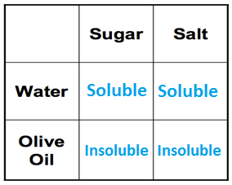
7. If there is too much of a solute in a solvent, then the solution is supersaturated.
8. If there is a perfect amount of solute dissolved into a solvent, then the solution is saturated.
9. In each box to the right, write soluble or insoluble:

Matter Changing States Review:

____________________ Theory of Matter:
- Molecules are always moving. This is known as the kinetic theory of matter.
- We measure this kinetic energy with a thermometer as temperature.
- The greater the material's internal energy, the higher the temperature of that material.
- Heat is the energy flow between objects of different temperature.
- Heat and temperature are NOT the same.
- Brownian motion describes how visible particles are seen moving due to invisible molecules bumping into them.

Phase Change Descriptions:

Melting the change from solid to liquid.
Freezing the change from liquid to solid.
Vaporization the change from liquid to gas.
Evaporation vaporization from the surface of a liquid.
Boiling vaporization from within as well as from the surface of a liquid.
Condensation the change from gas to liquid.
Sublimation the change from solid to gas.
Deposition the change from gas to solid.

Fill in the phase changes in the blank provided.
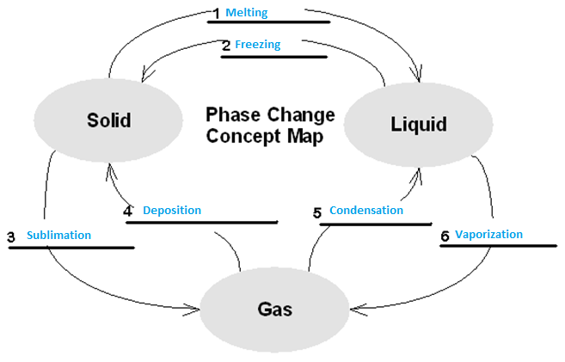

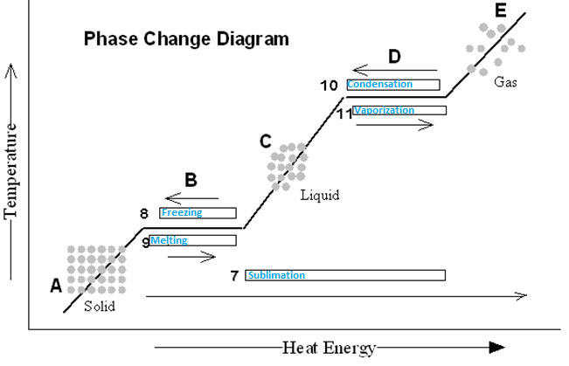

Phase Change Practice
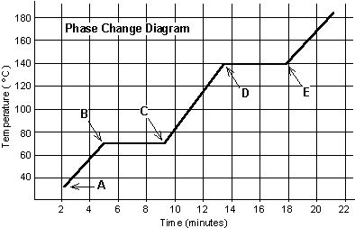
The graph was drawn from data collected as a substance was heated at a constant rate. Use the graph to answer the following questions.
At point A, the beginning of observations, the substance exists in a solid state. Material in this phase has definite volume and definite shape. With each passing minute, heat/ thermal energy is added to the substance. This causes the molecules of the substance to move more rapidly which we detect by a temperature rise in the substance. At point B, the temperature of the substance is 70°C. The solid begins to melt. At point C, the substance is completely melted or in a liquid state. Material in this phase has definite volume and indefinite shape. The energy put to the substance between minutes 5 and 9 was used to convert the substance from a solid to a liquid. This heat energy is called the latent heat of fusion.
Between 9 and 13 minutes, the added energy increases the temperature of the substance. During the time from point D to point E, the liquid is vaporizing. By point E, the substance is completely in the gas phase. Material in this phase has indefinite volume and indefinite shape. The energy put to the substance between minutes 13 and 18 converted the substance from a liquid to a gas state. This heat energy is called the latent heat of vaporization. Beyond point E, the substance is still in the gas phase, but the molecules are moving quickly/fast as indicated by the increasing temperature.
Substance | Melting point | Boiling point
Bolognium | 20 °C | 100 °C
Unobtainium | 40 °C | 140 °C
Foosium | 70 °C | 140 °C
Which of these three substances was likely used in this phase change experiment? __Foosium_

