**Matter Study Guide**

1. List two examples of a homogeneous solution mixture.  
2. List two examples of a heterogeneous colloid mixture.  
3. List one example of a heterogeneous suspension mixture.  
4. List two examples of elements.  
5. List two examples of a chemical formula.  
6. Category of mixture where substances are mixed evenly  
7. Category of mixture where particles are not mixed evenly  
8. The cloudy type of mixture that can scatter light where particles are too small to settle out.  
9. Type of mixture where particles are large enough to settle out or form layers   
10. Compare and contrast luminosity, apparent magnitude and absolute brightness.

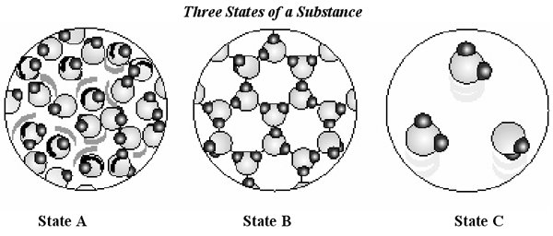

11. In which state are the particles least able to move?   
12. Which of the three states represents a liquid?   
13. If State A is heated, which of the other two states would it more closely resemble? Explain.

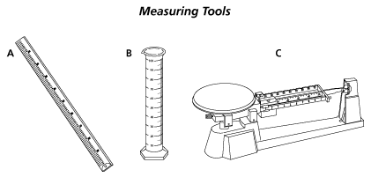

14. What does tool C measure?

15. What does tool B measure?

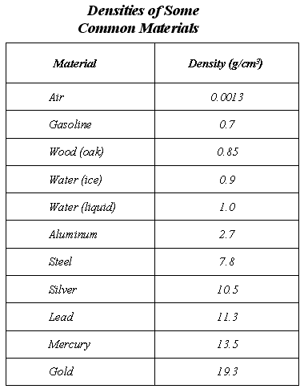

16. Which substance has the lowest density?

17. What is one substance that will float in water?

18. If samples of Aluminum and lead each had volumes equal to 1 cm3, which sample would have the greater mass? (use density formula)

19. Write PP, PC, CP or CC (Physical Property, Physical Change, Chemical Property or Chemical Change) for each below:  
a) conductivity  
b) burning sugar to produce Carbon  
c) solubility  
d) melting ice cream  
e) ability to corrode (like battery acid)   
f) viscosity  
g) melting   
h) condensation  
i) explosion

20. What is surface tension? ________________________________________________________________________________________________

Place a check mark next to all that apply below:



Match each diagram with its correct description. Diagrams will be used only once.

**A B C D E**

___1. Pure Element – only one type of atom present.  
___2. Mixture of two elements – two types of uncombined atoms present.  
___3. Pure compound – only one type of compound present.  
___4. Mixture of two compounds – two types of compounds present.  
___5. Mixture of a compound and an element.

**Density Practice:**

1. What is the formula for density?  
2. What are some of the units for density?  
3. If you increase the volume of a substance, what happens to the density?  
4. If you increase the mass of a substance, what happens to the density?   
5. If the density of a substance is 20 g/mL and the mass is 40 grams, what is the volume?

**Solutions:**

6. In the following solutions, identify the solutes and the solvents:

|  |  |  |
| --- | --- | --- |
| **Solution** | **Solute** | **Solvent** |
| Ocean water |  |  |
| Candy dissolving in mouth |  |  |
| Kool-Aid |  |  |
| Hot tea |  |  |

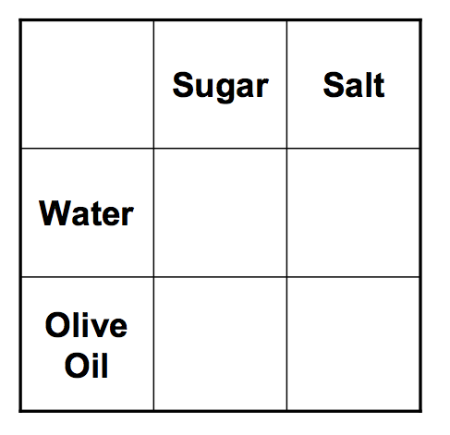  
  
7. If there is too much of a solute in a solvent, then the solution is ________________________________________.  
8. If there is a perfect amount of solute dissolved into a solvent, then the solution is _________________________________.

9. In each box to the right, write soluble or insoluble:

**Matter Changing States Review:**

## ____________________ Theory of Matter:

* Molecules are always moving. This is known as the kinetic theory of matter.
* We measure this kinetic energy with a thermometer as temperature.
* The greater the material's internal energy, the higher the temperature of that material.
* Heat is the energy flow between objects of different temperature.
* Heat and temperature are NOT the same.
* Brownian motion describes how visible particles are seen moving due to invisible molecules bumping into them.

## Phase Change Descriptions:

**Melting** the change from solid to liquid.

**Freezing** the change from liquid to solid.

**Vaporization** the change from liquid to gas.

**Evaporation** vaporization from the surface of a liquid.

**Boiling** vaporization from within as well as from the surface of a liquid.

**Condensation** the change from gas to liquid.

**Sublimation** the change from solid to gas.

**Deposition** the change from gas to solid.

Fill in the phase changes in the blank provided.  
  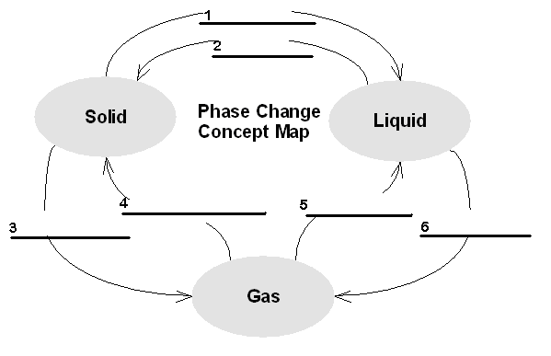

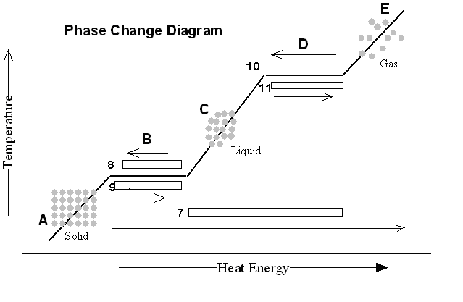

# Phase Change Practice

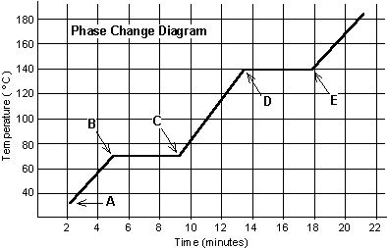The graph was drawn from data collected as a substance was heated at a constant rate. Use the graph to answer the following questions.

At **point A**, the beginning of observations, the substance exists in a solid state. Material in this phase has _______________ volume and _____________ shape. With each passing minute, _____________ is added to the substance. This causes the molecules of the substance to ____________ more rapidly which we detect by a ________________ rise in the substance. At **point B**, the temperature of the substance is ______°C. The solid begins to __________. At point C, the substance is completely ____________ or in a ___________ state. Material in this phase has _______________ volume and _____________ shape. The energy put to the substance between minutes 5 and 9 was used to convert the substance from a ___________ to a ___________. This heat energy is called the **latent heat of fusion**.

Between 9 and 13 minutes, the added energy increases the ______________ of the substance. During the time from **point D to point E**, the liquid is ___________. By **point E**, the substance is completely in the __________ phase. Material in this phase has _____________ volume and ___________ shape. The energy put to the substance between minutes 13 and 18 converted the substance from a ___________ to a ___________ state. This heat energy is called the **latent heat of vaporization**. Beyond **point E**, the substance is still in the ______________ phase, but the molecules are moving _______________ as indicated by the increasing temperature.

|  |  |  |
| --- | --- | --- |
| Substance | Melting point | Boiling point |
| Bolognium | 20 °C | 100 °C |
| Unobtainium | 40 °C | 140 °C |
| Foosium | 70 °C | 140 °C |

Which of these three substances was likely used in this phase change experiment? ______________________