Review for Human Body Test-Test Feb 4-5

- What is the name of the process by which the mitochondria in the cell take in glucose + oxygen and release energy?
- What is the name of the structures in the small intestines that absorb lots of nutrients?
- List the 3 functions of the skeleton.
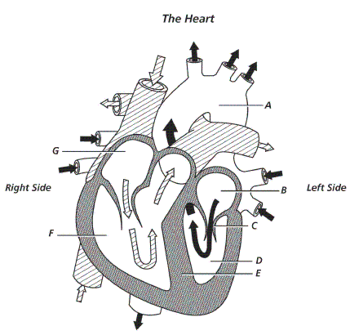

- Identify the chambers of the heat.
- What causes colds and flu to be spread?
- Define what a joint is?
- Where in the body are eggs produced?
- Where in the body are sperm produced?
- What type of organism (pathogen is a tapeworm?
- What organ system of the body protects the brain and spinal cord?
- Identify the structures of the digestive system and their functions.
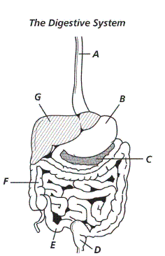
- Explain what happens to the diaphragm and rib cage during inhalation and exhalation.
- What is the function of the execratory system?
- What 2 organs make up the central nervous system?
- Where does cellular respiration take place, and what substances are produced during this process?
- What is the function of the circulatory system?
- What are the functions of the following organs: kidney, bladder, ureter, and urethra?
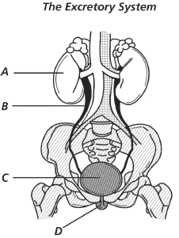

- Label the organs a-d of the excretory system.
- What is the function of the digestive system?
- What organ of the digestive system produces bile?
- List the 3 types of muscle and where they would by located.
- Explain what causes an infectious disease.
- What type of pathogen causes influenza?
- The first line of defense in fighting disease includes the skin. How does it protect us from disease?
- Define stimulus and response.
- What is the substance that the respiratory system brings into the body?
- Explain how pairs of skeletal muscles work together to allow move
- Where in the lungs does gas exchange take place?
- List the parts of your bodies 1st line of defense

- Why does your body need oxygen?

