Name _____________________________ Period _____

**Chemistry and the Periodic Table Packet – Project Grade**

**On the Periodic Table on the last page of this packet (lightly color so you can still read it):**

1. **Vertical columns** are called **families**. On your periodic table, label the vertical columns with the following labels: **Column 1 – Alkali Metals, Column 2 – Alkaline Metals, Column 13 – Boron Family, Column 14 – Carbon Family, Column 15 – Nitrogen Family, Column 16 - Oxygen Family, Column 17 – Halogens, Column 18 – Nobel Gases**  
 2. Using colored pencil, **LIGHTLY** color Hydrogen **yellow.**   
 3. **Horizontal rows** on the periodic table are called **Periods**. Number the seven rows on the periodic table using a marker (like “Period 1”, “Period 2”, etc.)  
 4. Elements in columns 3-12 are called **Transition Metals**. Color all  these elements all the same color. Label them.  
 5. Elements 58-71 are called **Lanthanoid Series.** Color these elements  all the same color.   
 6. Elements 90-103 are called **Actinoid Series**. Color these elements all  the same color.   
 7. Elements 5,14,32,33,51,52,84 are called **Metalloids**. Draw a black, zig-zag stair step line around these elements (like in your book) **and** in each of the boxes put a * to indicate they are metalloids.   
 8. Lightly color all metals one color not already used and color all non-metals **yellow**. Label above each category.

-----------------------------------------------------------------------------------------------------------------------------------------------------



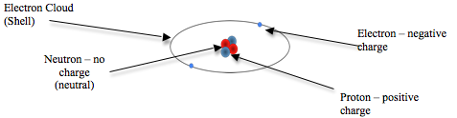All matter (air, water, soil, people) is made the elements on the Periodic Table. The smallest unit of one element that can exist on its own is called an **atom**. Atoms are made of a central **nucleus**, which contains **protons** and **neutrons**. Protons are positively charged and neutrons have no charge. Surrounding these nuclei are little negatively charged particles called **electrons**. The space around the nucleus that contains the electrons is called the **electron cloud or shell**.

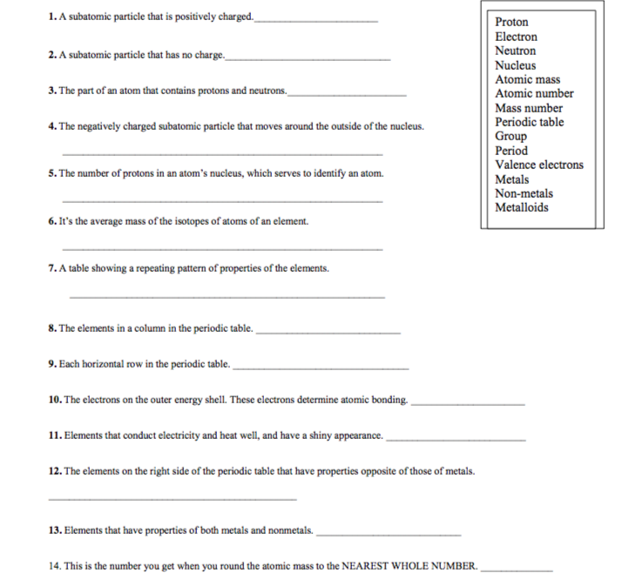

**A Brief History of the Periodic Table**

In addition to being different from each other because of the number of protons they possess, atoms also differ in their behavior. Potassium and sodium are extremely explosive in the presence of water, while a chunk of copper or silver would just sink effortlessly to the bottom of a swimming pool.  
 Dmitry Ivanovich Mendeleev (1834-1907) was a Russian chemist who proposed a method of arranging atoms according to their mass as well as their behavior. He noticed that certain elements behaved similarly to others, and he arranged these on his table so that they were in the same vertical row. For example, i**f you look at a periodic table of elements, you will notice that H, Li, Na, K, Rb, Cs, and Fr are all in the same vertical column. These elements all share common behaviors and also share a similar electron arrangement.**   
 Mendeleev's work is important to us today because he was able to successfully classify the chemical elements in order to give scientists a better understanding of how atoms interact with each other and of the properties they hold. **The periodic table organizes the elements into a grid of horizontal rows called periods and vertical columns called groups or families.** By setting up this periodic table, he was even successful in predicting the existence of at least three more elements that had yet to be discovered (gallium, scandium, and germanium).  
 Arranging elements by mass resulted in several elements being placed in groups of elements with different properties. Henry Mosely (1913) discovered that atoms of each element contain a unique number of protons in their nuclei (plural of nucleus), the number of protons being equal to the atomic number. Arranging the periodic table by atomic number, instead of mass, eliminated the problems with the Mendeleev’s periodic table.

**Why do elements in the same family generally have similar properties?** _________________________________________  
____________________________________________________________________________________________________

**The Modern Periodic Table:**

There are three main classifications for the elements- metals, nonmetals, and metalloids. **Metals** are elements that are generally shiny when smooth and clean, solid at room temperature, and good conductors of heat and electricity. Most metals are ductile and malleable, meaning that they can be pounded into thin sheets and drawn into wires.   
 Most group A elements and all group B elements are metals. If you look at boron (B), you see a heavy stair-step line that zigzags down to astatine (At) at the bottom of group 7A. This stair step line serves as a visual divider between the metals and the nonmetals on the table. Except for hydrogen, all of the elements on the left side of the table are metals. The group 1A elements (except for hydrogen) are known as the **alkali metals**. The group 2A elements are known as the **alkaline earth metals**. Both the alkali metals and the alkaline earth metals are chemically reactive, with the alkali metals being more reactive of the two groups.   
 The elements in the center of the periodic table are called **transition metals**. As with all metals, the transition elements are both ductile and malleable, and conduct electricity and heat. The interesting thing about transition metals is that their valence electrons, or the electrons they use to combine with other elements, are present in more than one shell. This is the reason why they often exhibit several common oxidation states. The 2 sets of inner transition metals, known as the lanthanide and actinide series, are located along the bottom of the periodic table.

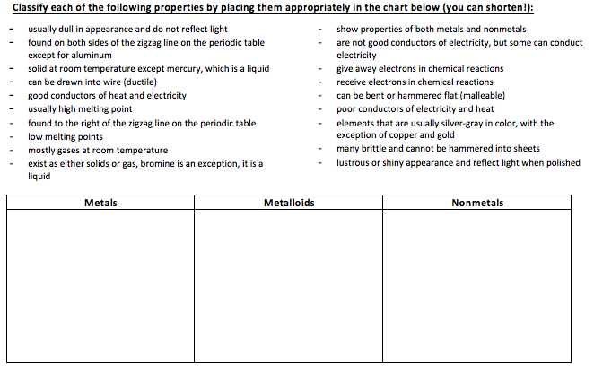

**Chemical Reaction:**

**Endothermic:**

**Exothermic:**



**Current Atomic Model:**

**Ionic Bond Formulas**

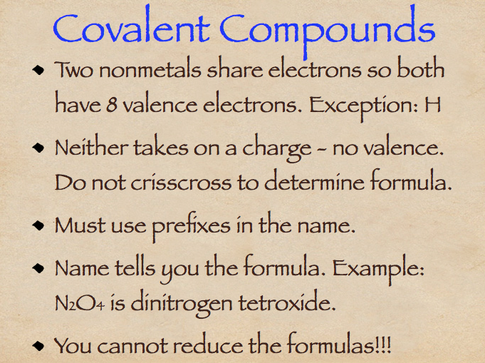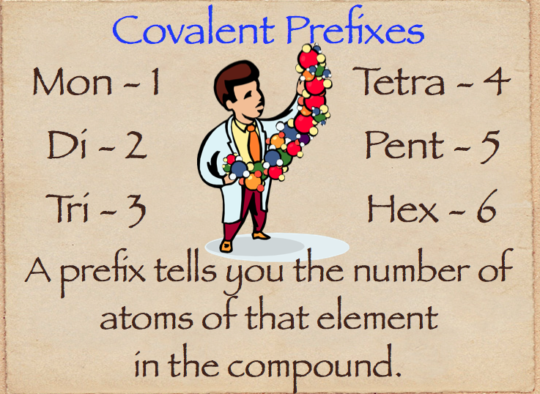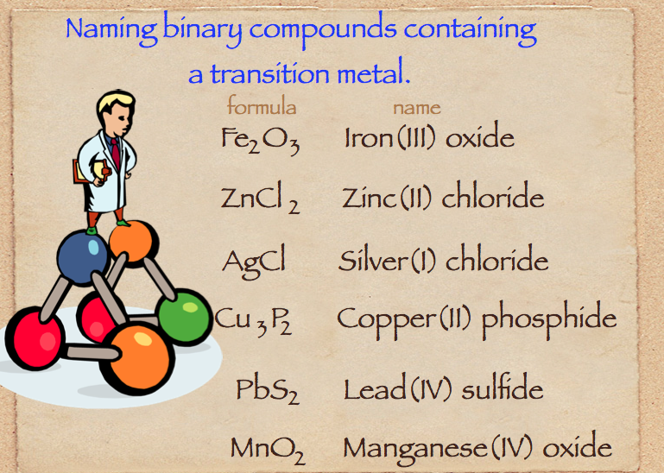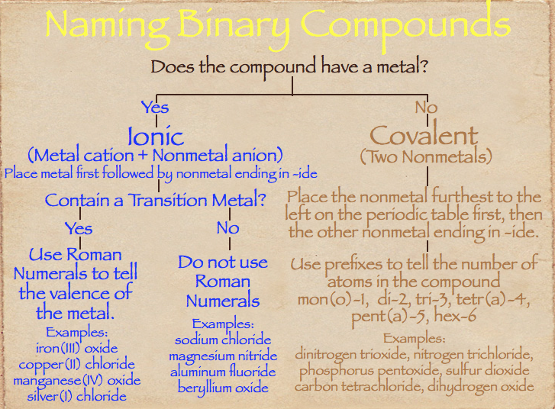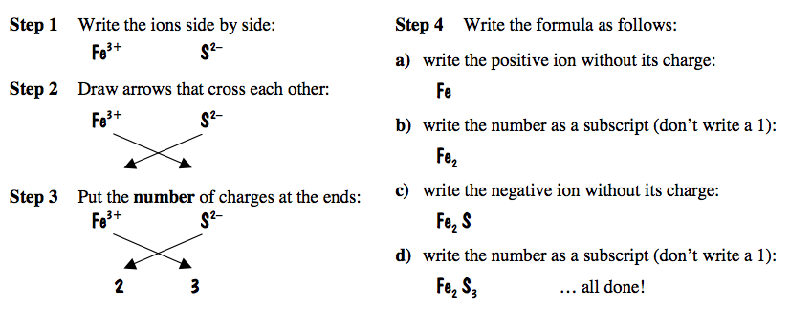

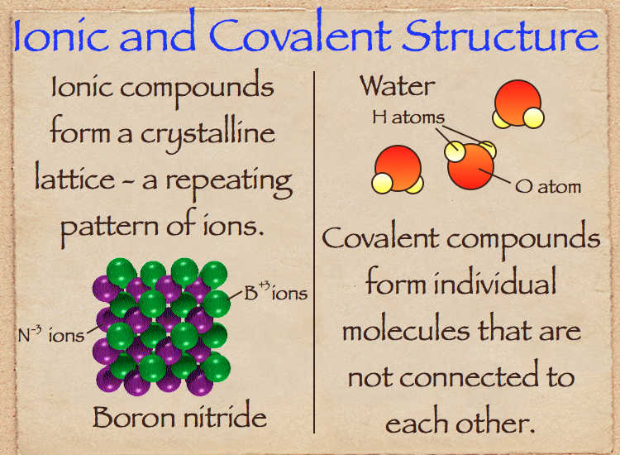

**Examples:**

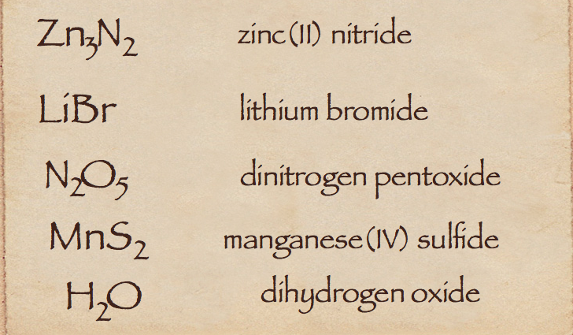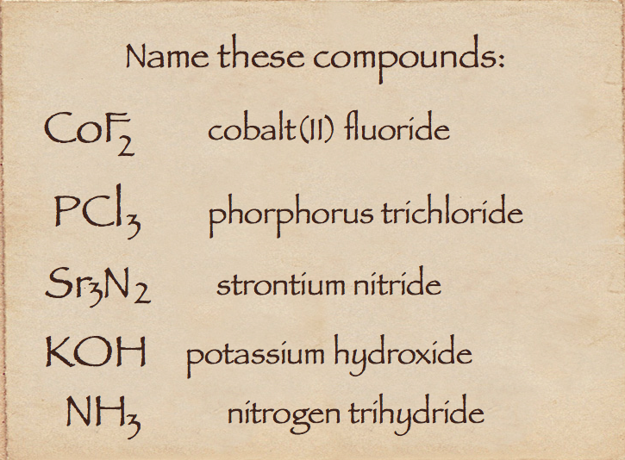

**Bonding Basics Practice**

**Ionic Bonds** - Draw the Lewis structures for each atom, then show the transfer of electrons and charge for each ion. Write the chemical formula for each compound.

(1) Mg + Br

(2) Pb +S

(3) Al + Cl

**Covalent Bonds** - Draw the Lewis structures for each atom, then draw circles to show the electrons that are shared. Write the chemical formula for each compound.

(1) H +Cl

(2) C +Cl

(3) Si+O

**ACIDS AND BASES NOTES WORKSHEET**

|  |  |  |
| --- | --- | --- |
| **ACIDS**  **An acid is a substance that:**  -Tastes sour (dangerous)  -Oily feeling (dangerous)  -Reacts with metals and carbonates  -Corrosive  -Turns blue litmus paper red  -All contain Hydrogen  -**Anything beginning with H is acid except water (H2O) and peroxide (H2O2)**   * **Cautions**:   Wash with water if it gets on you  Never smell  Don’t pour water into acid!  Don’t taste!!   * **Common Acids**   Lactic Acid = Buttermilk  Acetic Acid = Vinegar  Citric Acid = Oranges  Carbonic Acid = Cokes (carbonated water) | **BASES**  **A base is a substance that**:   * + Tastes bitter (dangerous)   + Slippery feeling (dangerous)   + Dissolves fats, oils, wool, & hair (lye)   + Turns red litmus paper blue   + Neutralizes acids to form salt and water.   **All have Hydroxides (OH)**  **Common Bases**   * + NH4OH = Ammonia   + NaOH = Lye   + Mg(OH)2 = Milk of Magnesia, Rolaids, Tums   + NaHCO3 = Sodium Bicarbonate: Baking Soda | **Indicators for the pH Scale**   * Litmus Paper   + Acids: blue litmus paper RED   + Bases: red litmus paper BLUE * Phenolphthalein   + Bases turn pink * Cabbage Juice   + Acids: pink/purple   + Neutrals: blue   + Bases: green * Beet Juice   + Acids: red   + Bases: purple |

|  |
| --- |
| **pH SCALE**   * The pH scale is a range of values from 0-14 that tells the concentration of Hydrogen ions in a solution. * 0 = Most Acidic * 7 = Neutral * 14 = Most Basic |

**Complete the following.**   
1. With a partner, take turns reading each other the information in the boxes above. Underline or highlight key things.  
2. Compare and contrast Acids and Bases.  
3. Explain the pH scale.  
4. What are indicators? What are the four types? What do they do?  
5. Give 5 examples of acids and 5 examples of bases. You can use Chapter 23 for extra help.  
6. Where does wine fall on the pH scale? Is it acidic or basic?  
7. Where does soap fall on the pH scale? Is it acidic or basic?  
8. Define: acid, hydronium ion, indicator, base, strong acid, strong base, weak acid, weak base, and pH.  
9. How can you tell an acid from a base by only looking at a chemical formula.  
10. What determines the strength of an acid? What about a base?  
11. Describe the pH values of 9.1, 1.2, and 5.7 as acidic, basic or neutral.

**Isotope Practice**

Use what you know about the structure of atoms to fill out the table below.

* ***Remember: Protons + Neutrons = the atomic mass***

|  |  |  |  |  |  |
| --- | --- | --- | --- | --- | --- |
| Isotope Name | Number of Protons | Number of Neutrons | Number of Electrons | Atomic Number | Atomic Mass |
| Nitrogen-17 | 7 | 10 | 7 | 7 | 17 |
|  |  | 0 | 1 | 1 |  |
|  | 11 |  | 11 |  | 23 |
|  |  | 8 | 6 | 6 |  |
|  | 17 |  | 17 |  | 35 |
| Carbon-13 |  |  |  |  |  |
|  | 12 | 12 | 12 |  |  |
|  |  | 10 | 9 | 9 |  |

1. Protons have a _____________________charge and are located in the _______________________.
2. Electrons have a __________________charge and are located in the _________________________.
3. Neutrons have a ___________________charge and are located in the ________________________.

--------------------------------------------------------------------------------------------------------------------------------------------------------------------

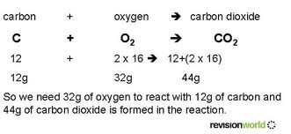The **Law of ________________________________________** states that the [mass](http://academickids.com/encyclopedia/index.php/Mass) of a system of substances is constant, regardless of the processes acting inside the system. It is also explained that [matter](http://academickids.com/encyclopedia/index.php/Matter) changes form, but cannot be created or destroyed. The mass or atoms in the reactant side of an equation must always equal the mass or atoms in the product side of an equation. Example)

**Mass of Reactants = Mass of Products**

|  |  |  |  |  |
| --- | --- | --- | --- | --- |
| **Reaction** | **Reactant(s)** | | **Product(s)** | |
| 1) | H2 | O2 | H2O |  |
| mass | 3.4g | 10g | 13.4g |  |
| 2) | CH4 | O2 | CO2 | H2O |
| mass | 12.2g | 14g |  | 20.0g |
| 3) | HgO |  | Hg | O2 |
| mass | 23.6g |  |  | 13.0g |
| 4) | Li | O2 | Li2O |  |
| mass |  | 5.7g | 24.6g |  |
| 5) | C3H6 | O2 | CO2 | H2O |
| mass | 18.9g | 11.1g |  | 15.6g | |
| 6) | Al(OH)3 |  | Al2O3 | H2O | |
| mass |  |  | 21.8g | 9.7g | |

**Count the Atoms to** **Determine if each equation is balanced or unbalanced**

1. AgNO3 + H2S 🡪 Ag2S + 2HNO3
2. Al + N2 🡪 2AlN
3. Fe2O3 + H2 🡪 2Fe + 3H2O
4. 3Zn(OH)2 + 2 H3PO4 🡪 Zn3(PO4)2 + 3 H2O
5. Mg(ClO3)2 🡪 MgCl2 + O2
6. Ba(NO3)2 + H3PO4 🡪 Ba3(PO4)2  + HNO3
7. Mg + AgNO3 🡪Mg(NO3)2 + Ag
8. CaCO3 🡪 CaO + CO2
9. CaO + CO2🡪 CaCO3
10. AlCl3(aq) + NaOH(aq) 🡪 NaAlO2(aq) + NaCl(aq) + H2O(l)
11. Cr(NO3)3 + NH3 🡪 Cr(NH3)6(NO3)3

**Balancing Chemical Equations: Introductory Stoichiometry**

1. **Write the unbalanced equation.**
   * Chemical formulas of reactants are listed on the lefthand side of the equation.
   * Products are listed on the righthand side of the equation.
   * Reactants and products are separated by putting an arrow between them to show the direction   
      of the reaction. Reactions at equilibrium will have arrows facing both directions.
2. **Balance the equation.**
   * Apply the [Law of Conservation of Mass](http://chemistry.about.com/od/chemistryglossary/a/conservmassdef.htm) to get the same number of atoms of every element on   
      each side of the equation.
   * Tip: Start by balancing an element that appears in only *one* reactant and product and save   
      Oxygen and Hydrogen for last.
   * Once one element is balanced, proceed to balance another, and another, until all elements are   
      balanced.
   * Balance chemical formulas by placing coefficients in front of them. Do not add subscripts,   
      because this will change the formulas.
3. **Indicate the states of matter of the reactants and products.**
   * Use (g) for gaseous substances.
   * Use (s) for solids.
   * Use (l) for liquids.
   * Use (aq) for species in solution in water.
   * Write the state of matter immediately following the formula of the substance it describes.

**Worked Example Problem**: Tin oxide is heated with hydrogen gas to form tin metal and water vapor. Write the balanced equation that describes this reaction.

1. **Write the unbalanced equation**: SnO2 + H2 → Sn + H2O
2. **Balance the equation.**   
   Look at the equation and see which elements are not balanced. In this case, there are two oxygen atoms on the lefthand side of the equation and only one on the righthand side. Correct this by putting a coefficient of 2 in front of water:

SnO2 + H2 → Sn + 2 H2O

This puts the hydrogen atoms out of balance. Now there are two hydrogen atoms on the left and four hydrogen atoms on the right. To get four hydrogen atoms on the right, add a coefficient of 2 for the hydrogen gas. Remember, coefficients are multipliers, so if we write 2 H2O it denotes 2x2=4 hydrogen atoms and 2x1=2 oxygen atoms.

SnO2 + 2 H2 → Sn + 2 H2O

The equation is now balanced. Be sure to double-check your math! Each side of the equation has 1 atom of Sn, 2 atoms of O, and 4 atoms of H.

1. **Indicate the physical states of the reactants and products.**   
   To do this, you need to be familiar with the properties of various compounds or you need to be told what the phases are for the chemicals in the reaction. Oxides are solids, hydrogen forms a diatomic gas, tin is a solid, and the term 'water vapor' indicates that water is in the gas phase:

SnO2(s) + 2 H2(g) → Sn(s) + 2 H2O(g)

**PRACTICE:**

1) ____ Na3PO4 + ____ KOH 🡪 ____ NaOH + ____ K3PO4

2) ____ MgF2 + ____ Li2CO3 🡪 ____ MgCO3 + ____ LiF

3) ____ P4 + ____ O2 🡪 ____ P2O3

4) ____ RbNO3 + ____ BeF2 🡪 ____ Be(NO3)2 + ____ RbF

5) ____ AgNO3 + ____ Cu 🡪 ____ Cu(NO3)2 + ____ Ag

6) ____ CF4 + ____ Br2 🡪 ____ CBr4 + ____ F2

7) ____ HCN + ____ CuSO4 🡪 ____ H2SO4 + ____ Cu(CN)2

8) ____ GaF3 + ____ Cs 🡪 ____ CsF + ____ Ga

9) ____ BaS + ____ PtF2 🡪 ____ BaF2 + ____ PtS

10) ____ N2 + ____ H2 🡪 ____ NH3

11) ____ NaF + ____ Br2 🡪 ____ NaBr + ____ F2

12) ____ Pb(OH)2 + ____ HCl 🡪 ____ H2O + ____ PbCl2

13) ____ AlBr3 + ____ K2SO4 🡪 ____ KBr + ____ Al2(SO4)3

14) ____ CH4 + ____ O2 🡪 ____ CO2 + ____ H2O

15) ____ Na3PO4 + ____ CaCl2 🡪 ____ NaCl + ____ Ca3(PO4)2

16) ____ K + ____ Cl2 🡪 ____ KCl

17) ____ Al + ____ HCl 🡪 ____ H2 + ____ AlCl3

18) ____ N2 + ____ F2 🡪 ____ NF3

19) ____ SO2 + ____ Li2Se 🡪 ____ SSe2 + ____ Li2O

20) ____ NH3 + ____ H2SO4 🡪 ____ (NH4)2SO4

**Chemistry Reference Sheet**

**chemical formula** tells the elements in a chemical compound and the exact # of elements of each atom  
**chemical bond** force that holds atoms together in a compound – valence electrons are gained or lost  
**compound** substance formed by 2+ elements – proportion is always the same  
**ion** charged particle because it gains or loses electrons – not balanced & holds   
 compounds together  
**ionic bond**  force of attraction between opposite charges of ions in a compound - transfer of   
 electrons from metals and non-metals  
**covalent bond** sharing electrons due to attraction – forms neutral particles/molecules  
**molecule** neutral particles formed by a covalent bond  
**chemical reaction** change where 1 or more substances are converted into new substances -  
 REACTANTS yield PRODUCTS (REACTANTS PRODUCTS)  
**reactants**  substances that react to form products (first part of a reaction)  
**products** new substances produced (by the reactants)

[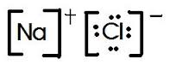](http://www.google.com/imgres?um=1&hl=en&safe=active&sa=N&rls=com.microsoft:en-us:IE-SearchBox&biw=1010&bih=560&tbm=isch&tbnid=FEIegxgfer5pYM:&imgrefurl=http://edtech2.boisestate.edu/lindabennett1/502/Compounds%20and%20Naming/Lewis%20Dot.html&docid=2-ZWv3OW8yQM6M&imgurl=http://edtech2.boisestate.edu/lindabennett1/images/NaCl%20lewis%20dot.jpeg&w=264&h=104&ei=lLBAUYH_E4im8ASTx4CIDw&zoom=1&iact=hc&vpx=7&vpy=257&dur=749&hovh=83&hovw=211&tx=96&ty=46&page=3&tbnh=83&tbnw=211&start=36&ndsp=20&ved=1t:429,r:47,s:0,i:229)H2O water  
NaCl sodium chloride = sodium + chlorine (table salt)   
C12H22O11 cane sugar (sucrose) – calcium, hydrogen, oxygenMg(OH)2 milk of magnesia (magnesium hydroxide)  
HCl stomach acid (hydrochloric acid)  
NH3 ammonia ion  
SiO2 sand (silicon dioxide)N2O laughing gas (dinitrogen oxide)  
C2H5OH grain alcohol and ethanol  
H2SO4 battery acid (sulfuric acid)

**Chemical Equation**  
way to describe a reaction using chemical formulas & other symbols (p. 635 blue book Table 1 symbols)  
(a reaction can give off heat or it can need heat to react)  
**Balanced Chemical Equation**  
both sides of the equation have the same numbers of element atoms  
**coefficients**  
numbers of units of each substance in a reaction  
**subscripts**  
number of atoms of a specific element (the subscript comes after the element it pertains to)  
**Law of Conservation of Mass**  
(leave space for the definition, we will watch a video clip to get the definition)  
**Steps to Balancing Equations**  
1) Write the chemical equation  
2) Count atoms in the reactants and products  
3) Choose coefficients to balance – try 2  
4) Adjust

