Test Corrections Rubric Name:
Quiz 9-16
Original Score Received ___________
- The essence of Wegener's idea was sound, based on some scientific observations. Which of the following supported his theory?
Describe Wegener’s other piece of evidence for continental drift: Puzzle Piece Earth
- Matching fossil plant remains found on two different continents
- Matching reptile remains found on two different continents
- nearly identical sedimentary rock types of same age in widely separated locations
- all of the above

- Mrs. McKay wanted to see how different types of music affected students' pulse rates. She played different types of music: heavy metal, rap, R&B, alternative, pop, country, and classical music. Identify the dependent variable.
Identify the independent variable. What could she have used for a control group? What could be one possible constant?

- types of music
- Mr. McKay
- high pulse rate
- pulse rate
- classical music resulted in the highest pulse rate

- Neptune’s existence was predicted because of the way it was changing the motion of Uranus. This is caused by the gravitational pull between Uranus and Neptune. If a gravitational pull exists, why is Uranus a planet and NOT a moon of Neptune?
Min 2 sentences: Explain the differences between a moon (satellite) and a planet.

A. Uranus is orbiting the Sun
B. Uranus has moons of its own.
C. Uranus is too far from Neptune
D. Uranus is too large to be a moon

- The Rocky Mountains are known for beautiful scenery. Which processes of the Rocky Mountains most likely required the longest period of time to occur?
List these answer choices based on time it takes to occur; from shortest to longest.
A. growth of plants and trees
B. formation of valleys from glaciers
C. large uplift of the land from tectonic forces
D. large accumulation of snow on the mountaintops

- Using the H-R diagram, which of these stars is both cool and bright?

- Rigel
- Alpha Centauri B
- White Dwarfs
- Antares
Three sentences describing how to read an H-R diagram.

- A layer of small rock and mineral particles can provide a surface for plant growth. Plants can eventually grow to cover this surface, while their roots spread out beneath the surface. Which natural process can most likely be reduced or prevented by the introduction of such plant growth?

A. erosion
B. flooding
C. weathering
D. soil formation

- Amanda has been studying the inheritance of traits in humans. She learned that unattached earlobes are dominant over attached earlobes The Punnett square shown below represents four children in one family. What are the genotypes of the parents?
Using the Punnett square to the left, (a) calculate the percentage of offspring that would have attached earlobes, (b) How could you change the genotype of one of the parents so that all offspring would have unattached earlobes?
F. EE and EE
G. Ee and Ee
H. EE and ee
I. ee and ee

- Using the table, which of these animals is most like a tiger (Panthera tigris)?
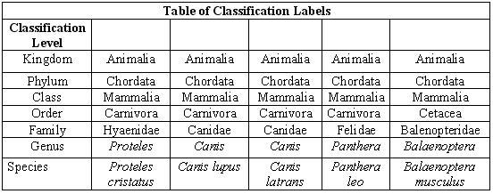
- Proteles cristatus
- Canis latrans
- Panthera leo
- Balaenoptera musculus

Email me this digital copy of the quiz corrections, or print it out and turn into the tray at school. If using email, write “Quiz Corrections 9-16” in the subject line.

Natalie_keene-krops@scps.k12.fl.us
- At what classification level do the species begin to differ?
- What do all organisms in the phylum Chordata have in common? (you may have to look it up).

