Test Corrections Rubric Name:
Quiz 1-8
Original Score Received ___________
- Sometime in the distant future, human astronauts want to travel to our nearest solar system neighbor; Proxima Centauri. This star is 4.22 lightyears away. If their ship could travel at half the speed of light how long would it take to reach this star system?
- 4.22 years
2 sentence explanation
- 422 years
- 8.44 years
- 211 years

- The reactants for photosynthesis are sunlight, water and carbon dioxide. What are the products?
2 sentence explanation or 1 sentence with a diagram
- Sunlight, water and oxygen
- Nitrogen, oxygen, helium
- Oxygen, glucose and heat energy
- Carbon dioxide, glucose and heat energy

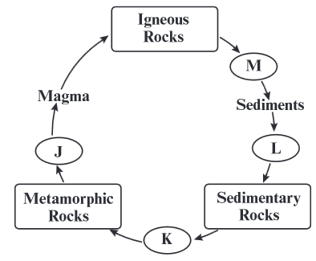
- Ice forms in the cracks of a basalt rock formation and breaks some rock into smaller pieces. The diagram below shows part of the rock cycle. At which point in the cycle shown above would the process of breaking down rocks occur?
- J
2 sentence explanation
- K
- L
- M

- Sonia wants to see how fast her new bean sprouts will grow. She plants on measuring them every day for the next 2 weeks. Sonia is performing an investigation. What could she add to her investigation to make it an experiment?
- By watering them every day
- By testing them with different amounts of water
- By creating a graph of her data
- By measuring their growth in metric units
Write are 3 things that experiments include that investigations do not.

- Bridgett, an astronomer uses a high-powered telescope to view objects in the universe. One night she sees a disk-shaped object that appears to have a huge number of twinkling lights swirling around a center point. What has Bridgett seen?
2 sentence explanation
- The universe
- A planet
- A black hole
- A galaxy

- Scientists can determine the absolute age of rocks using
Write a sentence explaining the difference between relative dating and absolute dating. Give one example of each.
A. Fault lines
B. Index fossils
C. Radioactive dating
D. the law of superposition

- Dean has started coughing and running a fever. He goes to the doctor. The doctor tells him that the type of pathogen he has is non-living, it reproduces inside of Dean’s cells and does not respond to anti-biotics. What does Dean most likely have?
What type of pathogen is the flu? Highlight two clues in the question that help you know what kind of pathogen it is.
- The Flu
- Strep Throat
- Athlete’s foot
- Tapeworm

- The Milky Way is a spiral galaxy, yet when Gordon looked at the stars one night, the Milky Way Galaxy looked like a flat band of stars across the sky. Why does the Milky Way Galaxy appear to be flat?
A. Earth is inside the Galaxy
B. Earth is close to the other stars in the Galaxy
C. Earth is rotating too quickly to view the Galaxy
D. Earth’s atmosphere distorts light from the Galaxy
2 sentence explanation

