Science Fair Tips and Information Packet
Intel ISEF International Science Fair

Official Rules: https://student.societyforscience.org/international-rules-pre-college-science-research
Official Forms: https://student.societyforscience.org/forms
Official Resources for Teachers and Students: https://student.societyforscience.org/resources-2
SCPS County Resources: http://www.scps.k12.fl.us/curriculum/AcademicCore/Science/SecondaryScience/SCPSScienceFair/SCRMEFInformation.aspx
JHMS Science Fair Website: http://jhmssciencefair.weebly.com/
Ms. Wasson’s Class Science Fair Website: http://www.mswassonsclass.com/science-fair.html

Information about Forms
All forms are located at the Official Forms site listed above (https://student.societyforscience.org/forms). The specific required forms for Science Fair projects will be sent to you as documents. I will be sending you samples of forms.
All projects need a form 1, 1A and 1B form (before the experiment is conducted) and a completed Abstract form (when the experiment is complete). The Risk Assessment (Form 3) is required for all students going to the fair and it is highly recommended for all projects. Any projects that involve humans (even if it is just for surveys), animals (which are typically not allowed) or hazardous chemicals require additional special forms. Visit the links above to locate the required forms and/or ask Wasson or Moreno about what is required. Special projects require special preapproval – students cannot start their experiments until they receive this special approval through the county.

Form Samples and Additional Notes
(see samples of forms provided to you):

- The forms must be typed or filled out neatly and clearly in pen. There can be no errors. The entire form will need to be redone if it is not filled out correctly.
- The Adult Sponsor is the Teacher
- Form 1 is filled out by the Sponsor (teacher) – You can do this form last
- Forms 1A and 1B are filled out by the students and Form 1B is signed by the parent
- The Supervisor is a Parent or Qualified Scientist (depending on the type of project)
- The Date of Review on Form 1 and the Dates on Form 1B need to be BEFORE the experiment Start Date on Form 1A. The Start Date on form 1A must be a future date for after the student(s) obtain approval.
- The form 1A end date can be your final due date for the project.
- Form 3 needs to contain detailed explanations of all potential risks involved in the experiment and it needs sources of safety information and a description of all safety precautions to be taken
- For any chemicals being used, the MSDS reference needs to be in the bibliography
- For sources, minimum of 5 “high-quality” sources (like articles or books), in a consistent format (MLA or APA) and in alpha order. The ISEF Guidebook is a required source. For chemicals, you need a MSDS reference. For health-related risks, you need an OSHA reference. For human projects, the Protection of Human Subjects document is a required source. You also need sources of safety information for all risks listed on your risk assessment.

Research Plan
This needs to be submitted and approved by the teacher before students begin their experiments. For special projects, the research plan needs to be submitted along with the special forms for pre-approval. See Ms. Wasson or Ms. Moreno for more information about this. Please have students type their plan on the school template that has been sent to you. There are also instructions to help students with their research plans.

Logbook
- Bound notebook or composition book
- Label in permanent ink on the cover: your full name, school address, teacher’s name and school phone number on the cover.
- Copy of the research plan and bibliography in the front of the logbook
- Table of Contents started
- Pages numbered – every page must have a new number
- Every new entry (for each new date) needs to be started on a new page number

Additional Logbook Requirements:
- Every entry should be dated, note place, time and exactly what you did
- Each date should be on a new page
- Start with your topic search, including any ideas you have
- Include your background research and sources
- Give a brief review of literature you reviewed
- Include ideas you thought of while researching
- Your problem and hypothesis
- Description and list of materials
- Description and list of equipment needed
- Specific Instructions and Procedures
- Raw data, charts and tables (any rough drafts and final copies) and pictures
- All experimental observations
- Anything in addition to your data you noticed during your experiment
- Data analysis with equations and/or calculations, if possible
- Include any special precautions for chemicals used that require special care
- Include disposal information for anything potentially dangerous

Abstract

This form (on the forms website listed above and sent to you already) needs to be completed after students complete their experiments. Students who are not going to the fair do not require this specific form, however, they still should complete an abstract.

Abstracts are limited to a maximum 250 words and must fit within the predefined area. Please be sure to consult the information from your affiliate fair for the proper formatting of the header information as fairs differ in what is required (or not allowed).

The abstract should include the following:
a) purpose of the experiment
) procedure
c) data
d) conclusions
It may also include any possible research applications. Only minimal reference to previous work may be included.

An abstract must not include the following:
a) acknowledgments (including naming the research institution and/or mentor with which you were working), or self-promotions and external endorsements
b) work or procedures done by the mentor

Sample Show Board:
Use all of board.
Use large font so it can be read from a distance.
Cut paper neatly and mount all on construction paper and then on show board.
All photographs, charts and graphs must be labeled with a title or caption and a citation of the source.
No people can be in the photographs (unless special permission forms – this is not advised)
Use rubber cement.
Tri-Fold show boards available at school store for $4-$5 or at drugstores or craft stores like Michaels. We have a few extra boards available for students who are unable to purchase one.
Problem  This must be in the form of a question  Purpose  Why you did the experiment and how is it relevant to others.  Hypothesis  This is your prediction of what would happen—do not use the words, “I think…”  Be specific  If, then, because statement.  Abstract  This is a summary of your experiment and results and must be typed on a special form available at www.sciserv.org  Do not mount this paper and do not cut it. It must be 81/2 by 11 and 12 font times new Roman. | TITLE IN BOLD LETTERS  It can be across the whole board.  It should be catchy and interesting.  Use the middle for graphs, charts, photos and other information. You must have at least 1 chart and 1 graph and pictures that do not contain people. (You should probably have more than one of each!)  *All charts and graphs must have a source (that would be you if you created it) and a caption. | Materials  Procedure  List the exact steps you followed in conducting the experiment. All measurements must be in metrics. It should be so clear someone else could read and do your experiment  Results  Tell the results in words  Conclusion  Tell whether the data supported the hypothesis and restate what happened.  You may also want to analyze what happened or give future ramifications of the results.

What the judges look for…

Visual Display
Is the project neat, attractive and visually pleasing? (correct spelling, arrangement and neat gluing)

Scientific Thought
- Does the display board show the steps of the Scientific Method? (independent variable and dependent variable in if-then hypothesis , evidence of a control, procedure in future tense with metrics units, results and conclusion)
- Graphs with explanatory titles, axes labels and units
- Photographs labeled so we know what they are and who took them
- Sufficient data supports the conclusion
- Creative/unique idea or method, a relevant topic, high-level topic
Project Clarity
- Abstract: explains project in correct format on official form
- All board items correctly and completely explain all project components

Additional Important Information

- All photographs, charts and graphs must be labeled with a title or caption and a citation of the source.
- No people can be in the photographs (unless special permission forms – this is not advised)
- No organic material on the boards
- For the school fair only, there can be no props to display – only the board is displayed
- If students go to the regional fair (after placing at our school fair), they can bring props, but no glass or breakable materials allowed.

Required Common Grading Rubric
(for Final Project Grade Calculations)
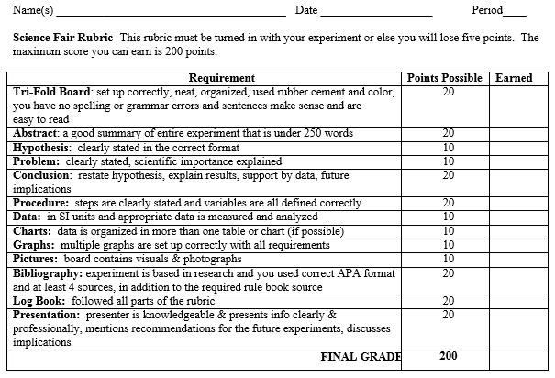

Detailed Grading Rubric for Students

Page One:
251658240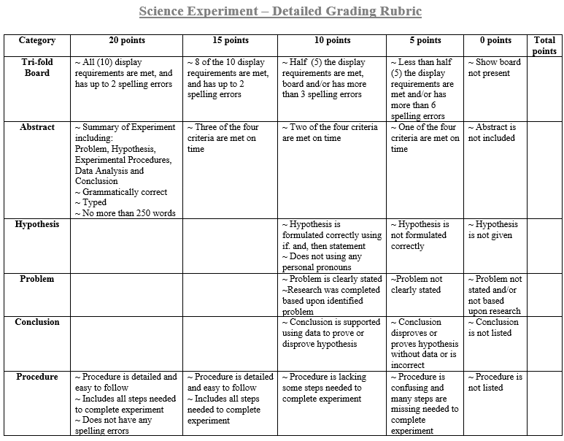

Page Two:

251658240