Name___________________
Francesco Redi
Directions: Answer the all questions in complete sentences.

1.) Make a prediction about the content of the text based solely on the below picture: _______________________________________________________________________________________________________________________________________________________________________________________________________________________________________________________________________________________________________(10 pts)
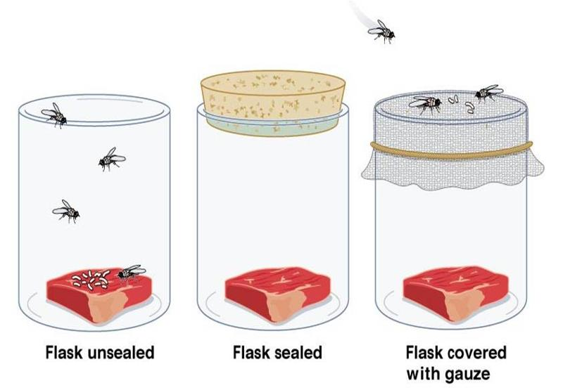
As you read the text underline any words that you need clarified in brown or black. (10 pts)

Francesco Redi was born in Italy in 1626. At age 21, he received a medical degree from the
University of Pisa, Italy. From then on, he worked as a doctor. Most of the people of Redi’s time thought living things came spontaneously from mud or decaying meat. They believed in the theory of spontaneous generation. A few scientists, including Redi, thought that idea was probably not true. He decided to try to find out how maggots appeared in decaying meat.Many thought the maggots came from the meat, but Redi thought that flies laid their eggs on the meat and the maggots hatched from those eggs.

To test his hypothesis, Redi prepared eight containers. Into each he placed a piece of meat
or fish. He then sealed four of the containers and left four uncovered. Drawn by the smell of
the meat, flies buzzed around the containers. After a few days, maggots appeared on the meat
in the four uncovered containers. The meat in the four covered containers had decayed, but
there were no maggots.
Next, Redi prepared eight more containers for a second experiment. Into each, he placed a
piece of meat or fish. He then covered four of the containers with gauze, which allowed air to
move freely in and out of the containers. He again left four containers uncovered. As before,
flies buzzed around the containers, attracted by the smell of the meat. After a few days the
results were the same—maggots could be found only on the meat in the uncovered containers

2.) Before the 1700s, some people believed that life came from mud or decaying meat. What is this theory called? _____________________________________________________________(10 pts)
Underline evidence from the text in red (5 pts).

3.) In the first experiment, what did Redi how? ___________________________________________________________________________________________________________________________________________________________________________________________________ (10 pts)
Underline evidence from the text in blue (5 pts).

4.) What did Redi do differently in the second experiment? ______________________________________________________________________________________________________________________________________________________________________________________________________________________________________________________________________(10 pts)
Underline evidence from the text in yellow (5 pts).

5.) What did Redi show in the second experiment that he had not already shown in the first? _________________________________________________________________________________________________________________________________________________________________________________________________________________________________________________________________________________________________________________________________________ (10 pts)
Underline evidence from the text in green (5 pts).

6.) After reading this text what questions do you have that you would like to have answered? List at least two. ______________________________________________________________________________________________________________________________________________________________________________________________________________________________________________________________________(10 pts)

7.) Use one sentence to summarize the main idea of this text. ______________________________________________________________________________________________________________________________________________________________________________________________________________________________________________________________________ (10 pts)

