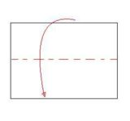**Egg Lab Foldable**

1. Start with a piece of white paper. Fold it in half (hot dog style).

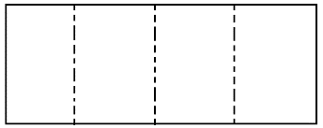

1. Fold it in half two more times so it looks like the picture to the right 🡪

**Open ends**

1. 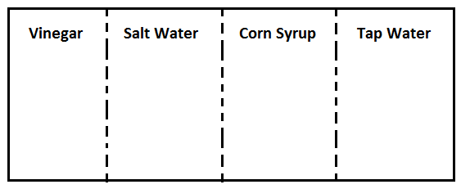With the connected edge at the top, label each box: **vinegar, salt water, corn syrup, tap water**

**Vinegar**

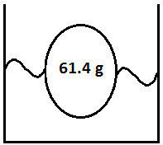

1. Open up your foldable. On the top rectangles, you will draw your before and after egg pictures. Write the mass of your egg inside the egg in your pictures. Include the type of liquid the egg was in for that portion of the experiment and the day(s) it was in them.

**Before**

**Friday-Monday**

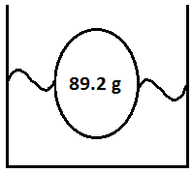

**After**

1. On the bottom rectangles, describe *in words* what happened to your egg.
   1. Identify the process (diffusion, osmosis)
   2. Describe the change in mass and circumference
   3. Describe what represented the high and low concentrations for each part of the experiment

***See the example to the right***

~Olive oil diffused from the egg (high concentration) into the cup (lower concentration)

~ Caused the mass and circumference to decrease

~ Diffusion took place

1. Put your name and period on the back of your foldable.