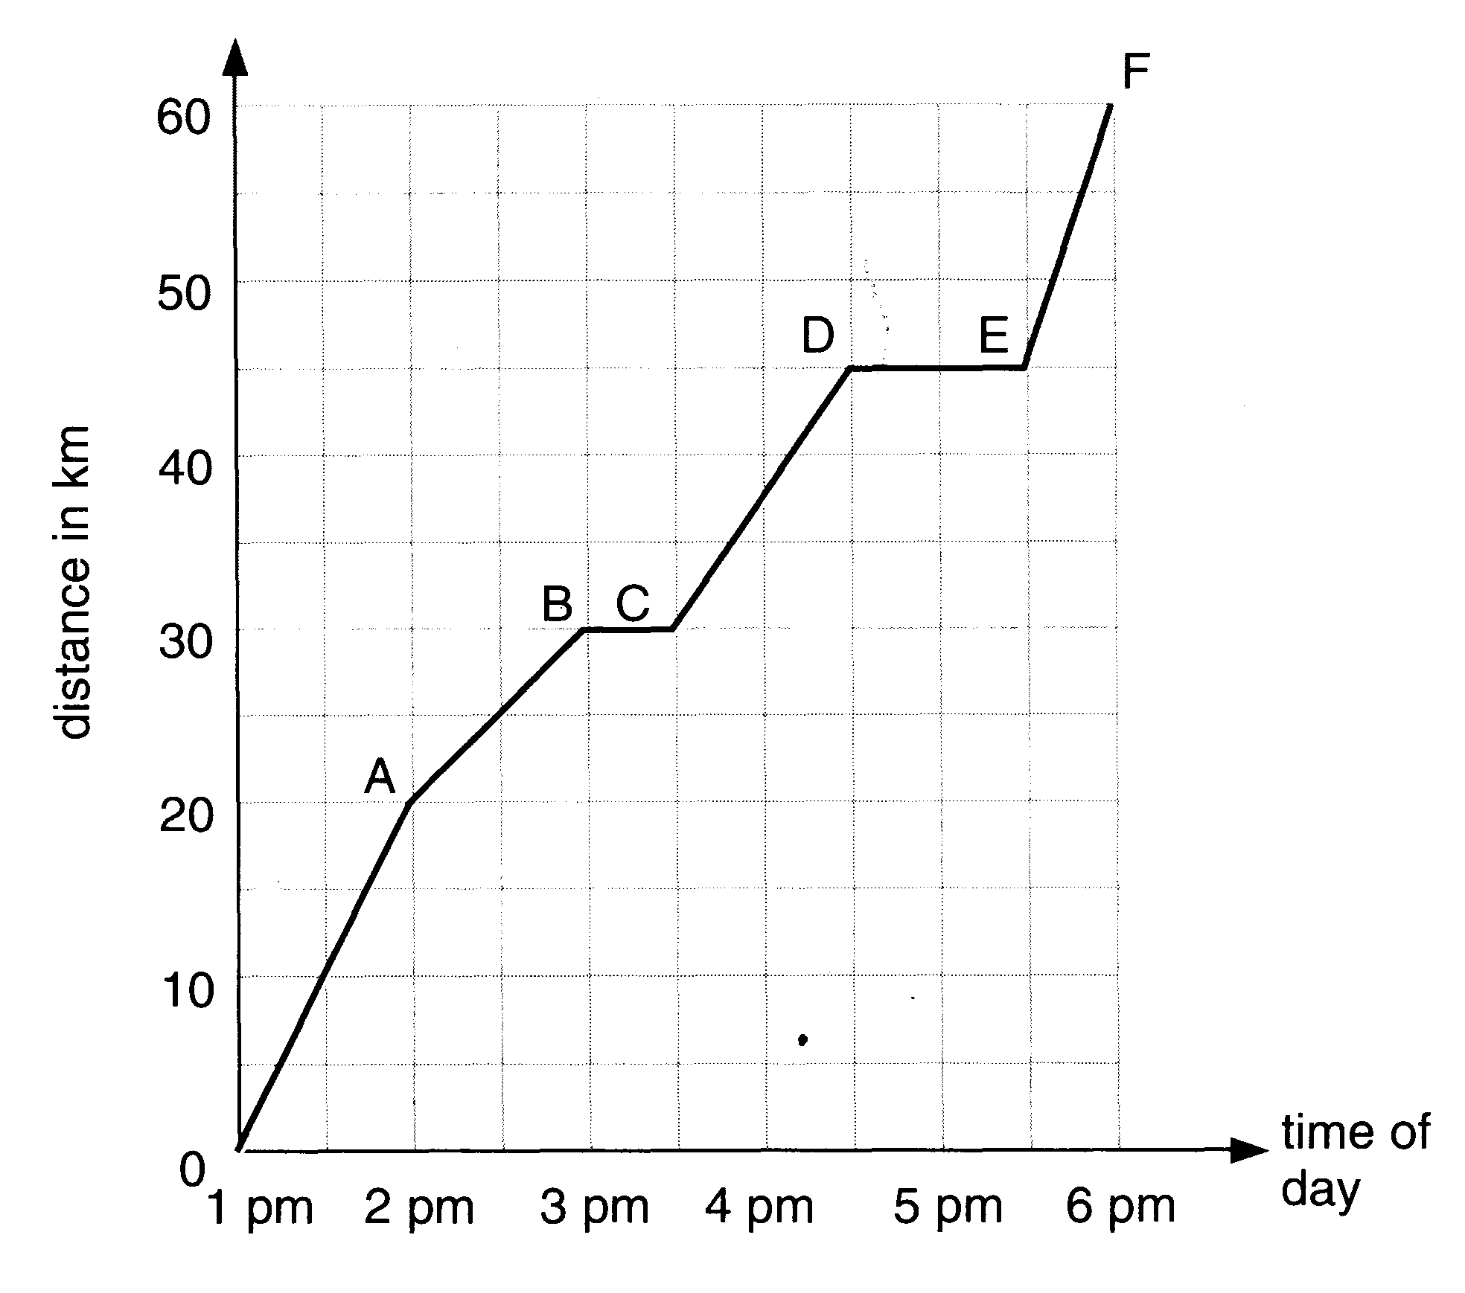

The distance - time graph for a girl on a cycle ride is shown in the figure above.
a. How far did she travel? _____________
b. How long did she take? ____
c. What was her average speed in km/h?

d. How many stops did she make? ___
e. How long did she stop for altogether? _____
f. What was her average speed excluding stops?

g. How can you tell from the shape of the graph when she travelled fastest? Over
which stage did this happen?

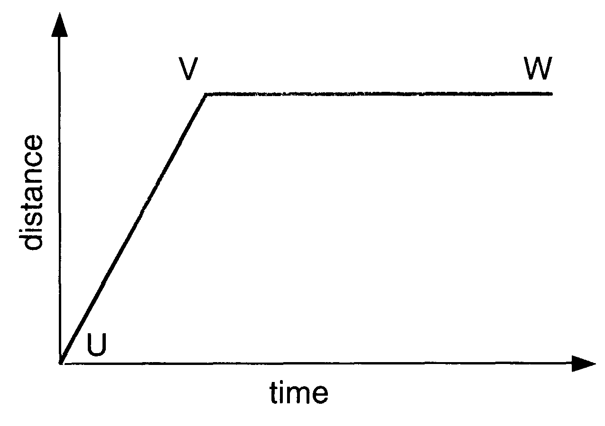 | This figure shows the distance - time graph for a moving object.  Describe the motion, if any, of the objects in the regions:  a UV:  b VW:

